On-Call Roles & Responsibilities for DirecTV Support
  - Structured Guidelines for On-Call, Backup, and Emergency Coverage Resources
Author: RAVI KC, DTV Delivery Manager
Review by : Nishant , Sunita , Pavithra & Khaja
This document outlines the roles and responsibilities for on-call, backup, and emergency coverage resources within the DirecTV Support team. It is designed to ensure uninterrupted service delivery, comprehensive 24×7 coverage, and swift escalation processes that are in line with DirecTV’s operational standards and expectations.

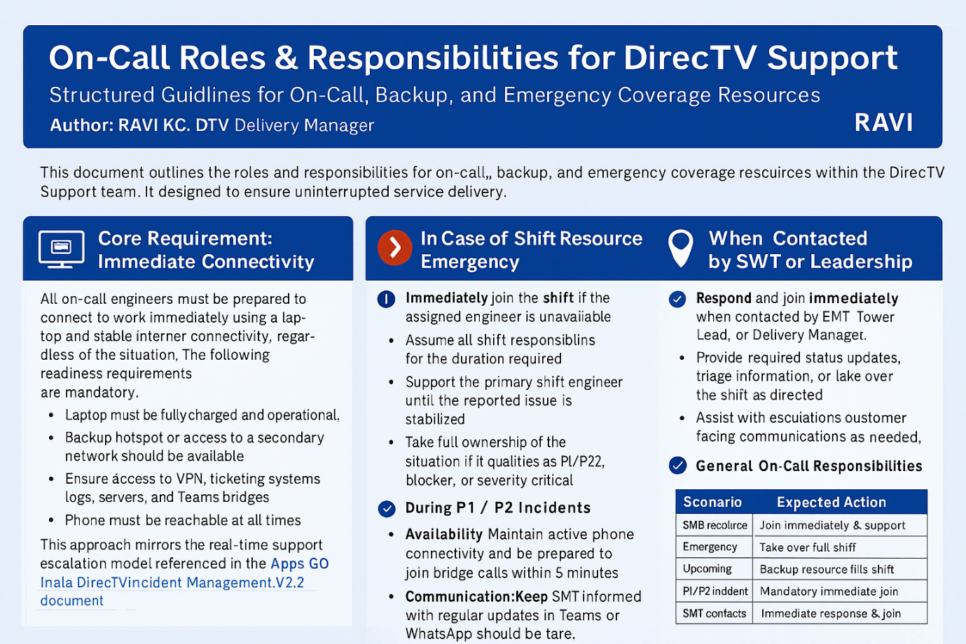

1. Core Requirement: Immediate Connectivity
All on-call engineers must be prepared to connect to work immediately using a laptop and stable internet connectivity, regardless of the situation. The following readiness requirements are mandatory:
- Laptop must be fully charged and operational.
- Backup hotspot or access to a secondary network should be available.
- Ensure access to VPN, ticketing systems, logs, servers, and Teams bridges.
- Phone must be reachable at all times.
- Current roster and escalation matrix must be accessible for quick reference.
These requirements are in alignment with the standards set forth during the DTV Thanksgiving 2025 Holiday IT Support Operations.

2. Scenario-Based Responsibilities

2.1. When the Shift Resource Requests Technical Support
- Respond immediately upon being contacted.
- Join the relevant bridge or Teams chat session.
- Support the primary shift engineer until the reported issue is stabilised.
- Take full ownership of the situation if it qualifies as P1/P2, blocker, or severity-critical incident.
This approach mirrors the real-time support escalation model referenced in the Apps GD India_DirecTV_Incident_Management_V2.2 document.

2.2. In Case of Shift Resource Emergency
- Immediately join the shift if the assigned engineer is unable to continue.
- Assume all shift responsibilities for the duration required.
- Continue in the role until formally relieved by the next scheduled resource.
- Promptly update the shift group, SMT, and lead regarding the situation and actions taken.
This process is consistent with the “emergency backup support” protocols described for OCE roles in DTV Thanksgiving 2025 Holiday IT Support Operations.

2.3. If the Upcoming Shift Resource Is Unavailable
- Step in and take over the shift if the incoming engineer is unavailable due to network issues, personal emergency, or travel constraints.
- Fulfil all shift deliverables, including triage, monitoring, on-call handling, SLA-sensitive items, and reporting tasks.
- Notify SMT and update the roster to reflect the change.
This upholds the on-call continuity expectations as emphasised in meeting discussions, where leaders stressed the importance of zero gaps in coverage and timely updates to the roster.

2.4. During P1 / P2 Incidents
- Join the response effort immediately for all Severity-1 or Severity-2 incidents, regardless of the time of day.
- Remain engaged until the incident is stabilised or appropriately handed off.
- Follow the escalation structure outlined in the DTV escalation matrix (L1 → L2 → L3).
- Participate actively in bridge calls, troubleshooting, communication, and root cause analysis preparation.
Expectations include no delays, no missed calls, and full ownership of the incident until it is resolved.

2.5. When Contacted by SMT or Leadership
- Respond and join immediately when contacted by SMT, Tower Lead, or Delivery Manager.
- Provide required status updates, triage information, or take over the shift as directed.
- Assist with escalations or customer-facing communications as needed.
This approach aligns with leadership engagement protocols established in DTV Thanksgiving 2025 Holiday IT Support Operations.

3. General On-Call Responsibilities
- Availability: Maintain active phone connectivity and be prepared to join bridge calls within 5 minutes and log in to systems within 10 minutes.
- Accountability: Complete root cause analysis inputs if an incident occurs during your backup window. Update ticket notes thoroughly and ensure a clean handover to the next shift.
- Communication: Keep SMT informed with regular updates in Teams or WhatsApp. Communicate proactively if temporarily unreachable, though such situations should be rare.

4. Non-Compliance / Failure to Join
- Instances of consistent non-responsiveness or inability to join must be escalated to SMT.
- Such occurrences should be documented in the shift review.
- Non-compliance may impact the reliability score of the resource involved.
This is in line with escalation norms described in meeting transcripts and incident management process documents.

5. Summary Table
Scenario | Expected Action
Shift resource asks for help | Join immediately & support
Shift resource emergency | Take over full shift
Upcoming shift resource unavailable | Backup resource fills shift
P1/P2 incident | Mandatory immediate join
SMT contacts | Immediate response & join
Under all circumstances | Must be able to connect via laptop + VPN

